

Software design and Architecture

Lab Report # 06



**Question 1:**

You have been asked to develop a system for a local Thai food takeaway shop named ABC. The system should allow customer to order their Thai curriers over the internet and collect them and pay at the shop. Customer do not register with the system but they need to supply a contact phone number. ABC has a price derived from its size, type (red, green or yellow) and protein A curry has only one protein (chicken, beef or pawn). Each type of protein has different price. Customer have orders and each order is for one customer. An order consists of number of items, and has a collection time. An item is a curry, rice or drink. To place an order a customer must supply a contact phone number and name. a person can order multiple items. When order is submitted the customer receives a confirmation message along with the final cost of an order and collection time. The system calculate the collection time based on the number of orders currently being processed and average time to fil an order. Once payment receipt is generated the system won’t allow customer to change or cancel his order

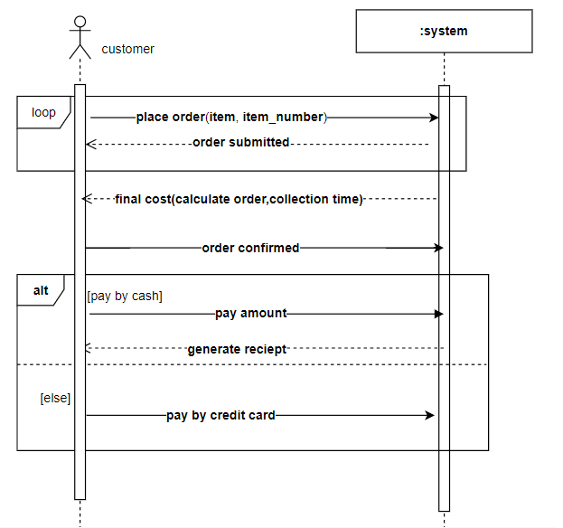

**Question 2:**

Draw SSD of any two use cases of social networking website.